Performance Testing
Script-Controlled ACL – Restrict Record Access Based on Field Value
Date | 30 September 2026
Team ID | SWTID-2026-7644
Project Name | Script-Controlled ACL – Restrict Record Access Based on Field Value
Maximum Marks | 5 Marks
Performance Testing
Performance testing evaluates how the ACL-based record access behaves during normal and repeated access requests. For this ServiceNow project, validation focuses on consistent ACL evaluation, record access behavior, and absence of functional errors.
Step 1: Testing Overview
Testing Tool Used | ServiceNow platform / manual access validation
Type of Testing | Access-response validation, repeated record access, consistency testing
Target Module / API | Institution Details table – Read ACL
Test Environment | ServiceNow instance
Test Date | 30 September 2026
Step 2: Test Scenarios
S.No | Test Scenario / Description | No. of Virtual Users | Duration (sec) | Expected Outcome
1 | Authorized field-value access | 1 | Manual validation | Permitted record is displayed when the configured ACL condition is satisfied.
2 | Unauthorized field-value access | 1 | Manual validation | Protected record is denied and restricted information is not exposed.
3 | Multiple record access with mixed values | 1 | Manual validation | Only records satisfying the configured access condition are accessible.
4 | Repeated ACL evaluation / script validation | 1 | Repeated requests | ACL decision remains consistent without observed functional errors.

Step 3: Performance Test Results
S.No | Metric | Target Value | Actual Value | Status (Pass / Fail) | Remarks
1 | Access Decision Response | No functional error observed | Validated manually | Pass | ACL returned the expected access decision.
2 | Repeated Access Consistency | Consistent result | Consistent during validation | Pass | Same ACL condition produced consistent behavior.
3 | Record Access Handling | Correct allow/deny behavior | Validated manually | Pass | Permitted and restricted records were handled correctly.
4 | Error Rate | No ACL-related functional error | No observed ACL error | Pass | No access-control error observed during validation.
5 | Security Rule Evaluation | Configured condition evaluated | Validated manually | Pass | Branch condition and script were evaluated.
6 | Data Protection | Restricted data not exposed | Validated manually | Pass | Unauthorized access to protected information was blocked.
Step 4: Observations & Analysis
Key Findings:
The ACL evaluated the configured field condition and authorization logic. Permitted records were accessible and restricted records were denied during validation.
Bottlenecks Identified:
No specific ACL-related functional bottleneck was observed during manual validation. Exact response-time measurements were not collected.
Optimization Steps Taken:
The ACL uses a focused read-access rule with a field condition and advanced authorization script to keep the access decision controlled and maintainable.
Step 5: Screenshots / Evidence
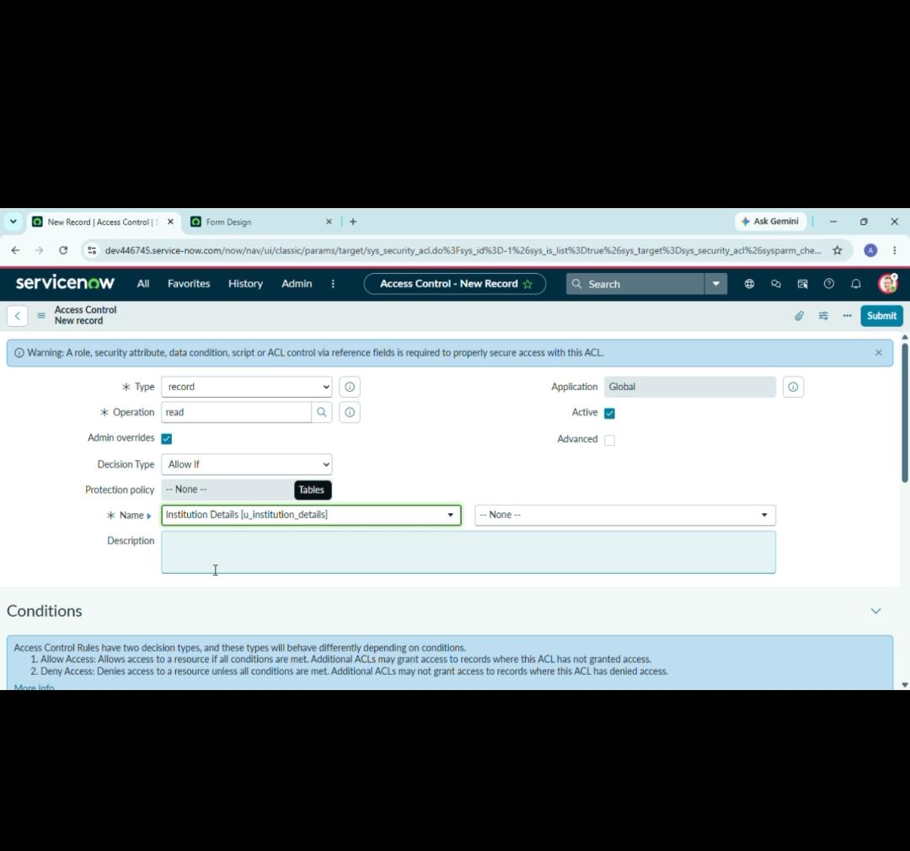
ACL Configuration
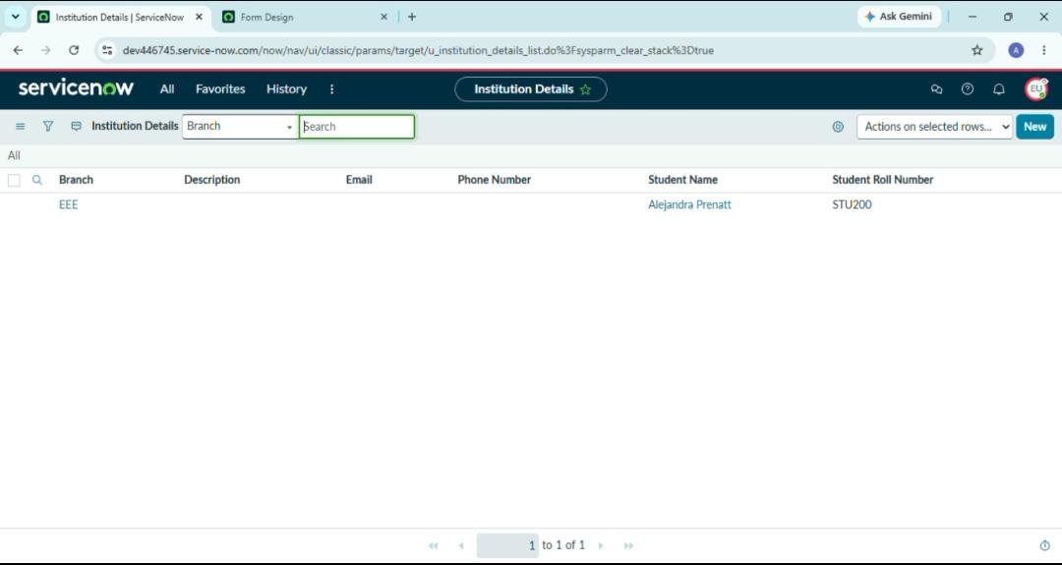
Final Access Result

